**Sensors in brief**

**Total no of Sensors:** 5

**RH sensor ---**> Air temperature+ RH

**Soil probe** **---**> Moisture content + compost temperature

**Air Flow** ---> L/min , **pH sensor**---> Compost pH , **CO2 sensor**---> ppm

**AIR FLOW SENSOR** (*D6F-02L2*)

Pin connections:

Brown: Vcc ; Blue: GRD

Black: analogue out (A0)

**CO2 SENSOR** (EZO-CO2)

Pin connections:

White: Rx/SCL ; Green: Tx/SDA

Black: GND ; Red: Vcc

Blue: ALM 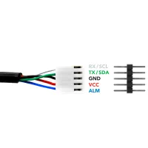

[Help](https://atlas-scientific.com/blog/co2-sensor-arduino/)

**Max 485**

DI- Rx/ Rxd ; RO-Tx/Txd ; DE,RE ::GPIO pins to Arduino

A,B – sensor wires

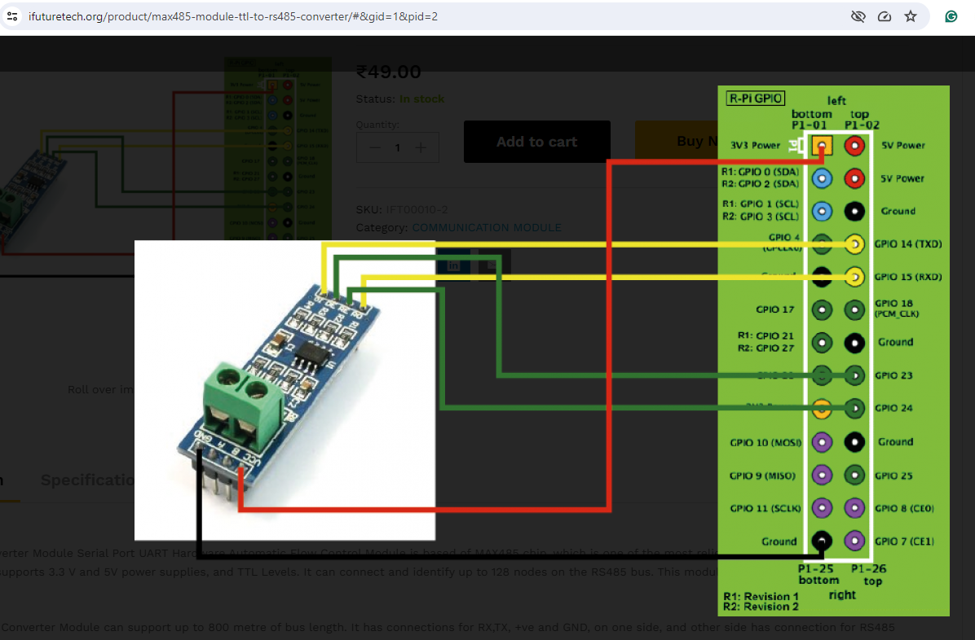

**Circuit Diagram**

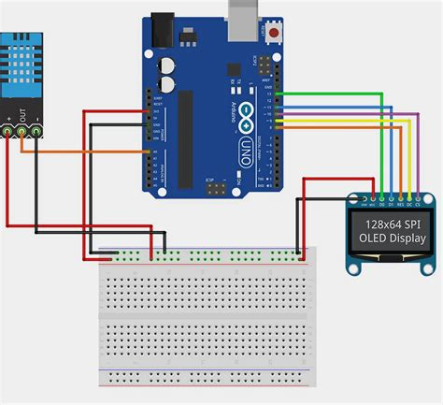

[DI(data in) -->Tx wire] --> Rx pin arduino

[RO(read out)-->RX wire]-->Tx pin arduino

#define Tx 2

#define Rx 3

SoftwareSerial myserial(Rx,Tx); // myserial( RO,DI)

________________________________________________________________________________

Details of sensors, their uses and profile

|  |  |  |  |  |  |
| --- | --- | --- | --- | --- | --- |
| List of Environmental Sensors used | | | | | |
| Global env Sensors | | | Local env Sensors | | |
| **RH sensor** | Relative Humidity | Air temperature | **Soil senor** | Moisture content of compost | Compost Temperature |
| **CO2 sensor** | CO2(ppm) | | **PH sensor** | Compost pH | |
|  |  |  | **Anemometer** | Airflow near compost surface | |

Total no of sensors in use: 5

|  |  |  |  |
| --- | --- | --- | --- |
| Position of sensors | | | |
| On the Harvester | | Off the harvester | |
| **RH sensor** | * RH needs 12-24V DC  * CO2 needs 3.3-5V DC | **Soil senor** | * Soil Sensor 12-24V DC  * PH meter and Anemometer are battery led |
| **CO2 sensor** | **pH meter** |
|  | **Anemometer** |

Some sensors are placed on the harvester what does not need compost interaction and more like air sensors than soil sensors. The rest would be handled manually by hand.

^threaded hole specification and drill through

^box for Arduino n wires

|  |  |  |  |
| --- | --- | --- | --- |
| Working with sensors | | | |
| On the Harvester | | Off the harvester (Hand hold) | |
| **RH sensor** | PS: RH sensor will take power supply from the harvester power box  Position: Screwed up to harvester  PS: CO2 sensor will take power supply from the industrial PC USB port  Position: Screwed up to harvester using 3D printed holder or taped around edge | **Soil senor** | PS: 12-24 V DC (battery)  *Need a station that can be moved along the shelf where sensors can be placed  Position: Hand hold. Might be placed in a frame for ease  Turn: At the same time Soil sensor is dipped in the compost for ease  PS: Rechargeable built-in battery(12V)  Position: Hand hold. Might be placed in a frame next to soil sensor  Turn: At the same time Soil sensor is dipped in the compost for ease  PS: 3 AAA Batteries  Position: Hand hold  Turn: Will be used at the end on its own |
| **CO2 sensor** | **pH meter** |
| **Anemometer** |

On-harvester sensors will take reading while harvester is on it move. Off-harvester sensors will be used manually. Soil and pH sensor can be managed together using holder while anemometer will be considered at the last. This is a suggestive working routine for a single full-scan.

|  |  |  |
| --- | --- | --- |
| Requirements | | |
| 12/24V DC from the Harvester (24V can be done from PLC)  (on the harvester) | A platform that can be moved along the shelf | Holder for CO2 |
| 12V DC from main/ 12V battery  (off the harvester) | Holder for soil and pH meter |
| 3X AAA batteries |

|  |  |  |  |
| --- | --- | --- | --- |
| On the harvester | | Off the harvester | |
| Arduino UNO | | Arduino orange | |
| CO2 | CO2(ppm) | Soil sensor | Compost moisture  Compost temp |
| RH | Air temp(*C)  Air humidity(%) |  | |
| Total readings | 3 | Total readings | 2 |
|  | | Board Not required | |
| PH meter | pH |
| Anemometer | Air speed(m/s) |

|  |  |
| --- | --- |
| Requirements | Requirements |
| Arduino PS : 7to 12VDC | Soil Sensor PS :12-24V DC |
| RH PS :12-24V DC |  |
|  |  |

**Data collection routine:**

First run the harvester, while it is on its move CO2 and RH will be recoded onto industrial PC’s hard drive.

On 2nd turn when the harvester is at rest, register compost parameters onto Ayan’s laptop where compost temperature and water content will be logged for future use.Ajay will poke the sesnor inside the bed and Ayan will manage the electrocics communication.

On 3rd turn, Ajay will do pH meter and Anemometer test while Ayan will register the reading corresponding to each meter onto a paper

At the end all sesnor and meter data will be fetched in a drive where it would be stored for future data processing

**Requirements**

1. Excel sheet for pH and Anemometer
2. Laptop changer, Arduino kit full set

-----

It is handy to have sscom software where

1. Station address/ Sensor id can be changed by passing command, 00 10 (Address) and passing command 00 20, one can verify if the sensor address is changed to the one which has been given lately through the return data pack

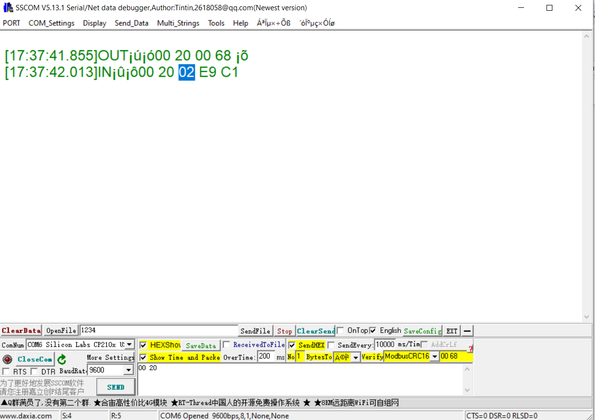

2. CRC bytes can be recognised. Send the enquiry frame with out CRC through the software interactive console and check the CRC being displayed just beside verify tab

For example, send **02 03 00 00 00 02** and CRC would be displayed as **C4 38.** Hence the enquiry data frame for address 00x02 would be **01 03 00 00 00 02 C4 38** while for address 00x01 it is **01 03 00 00 00 02 C4 0B**

Sensor wiring and Arduino pins

**2 3 4 5** : RH sensor

**8 9** : CO2

**A3 A2 A1 A0** : Other RS sensor (Compost probe)

Sensor box Turn ON-OFF red LED (Single switch for both battery?)

One switch One LED for Arduino – 3/5VLED with register

One switch One LED for sensor – 14V LED